**Installation Instructions**

Follow the instructions below to install the Quality Control plugin

1. Download the [Quality_Control.jar](http://code.google.com/p/um-qc/downloads/detail?name=Quality_Control.jar) file from the Downloads page
2. Download the [JFreechart jar](http://code.google.com/p/um-qc/downloads/detail?name=jfreechart-1.0.13.jar) (jfreechart-1.0.13.jar) from the Downloads page
3. Download the [JCommon jar](http://code.google.com/p/um-qc/downloads/detail?name=jcommon-1.0.16.jar) (jcommon-1.0.16.jar) from the Downloads page
4. Download the [JXL jar](http://um-qc.googlecode.com/files/jxl.jar) (jxl.jar) from the Downloads page
   * Any of the above third party jars (jxl, jfreechart, jcommon) can be downloaded from the original source by googling the name and navigating to the corresponding download page
5. Navigate to your ImageJ installation on your computer (for example mine is in **'C:\Program Files (x86)\ImageJ'** )
6. Navigate to the **plugins** folder in your ImageJ installation folder
7. Create a new folder in the **plugins** folder. Name the new folder **US_QC**
8. Copy all of the above jars (including the Quality_Control jar file) to the **US_QC** folder. Mine looks like this: 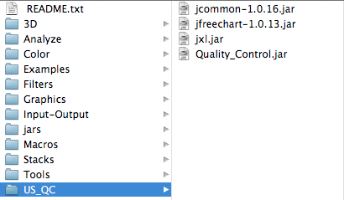
9. Open ImageJ and you should see a US_QC folder under the **Plugins** menu that has three plugins: _ 